Results Section DC Paper

**Results**

*Rate of spontaneous aneuploidy is nearly twice as high in hybrid strain than lab strain*

The rate of spontaneous aneuploidy in the heterozygous hybrid strain was 1.82 x 10-04 events per genome per generation. The homozygous lab strain had a significantly lower rate of 1.04 x 10-04 events per genome per generation, about half that of the heterozygous lab strain (*p*=0.0106, Fisher’s exact test, figure 1). Previous studies have found that chromosome V is lost spontaneously in *S. cerevisiae* at a rate of 2-8 x 10-6 cell generations (Mulla *et al.* 2014).

For the lab strain, 31 out of 145 sequenced samples were found to be aneuploid (Zhu *et al.* 2014). Of these, 29 had whole-chromosomal duplications, and 2 had whole-chromosomal deletions (Zhu *et al.* 2014). No segmental duplications were found in the lab strain samples. 4 samples contained multiple aneuploidies (i.e. two separate chromosomes had become aneuploid). Half of the chromosomes (8 total) were found to be aneuploid in multiple individual samples. In total, there were 29 trisomy events.

In the hybrid strain, 29 out of 76 sequenced samples were found to be aneuploid. Of these, 27 were trisomic, 1 was monosomic, and 1 was tetrasomic. One sample had a partial duplication of chromosome X. Eight of the hybrid strain samples contained multiple aneuploidies. In total, there were 38 trisomy events in the hybrid strain samples.

Across the two experiments (29+27 = 56 trisomies), expect this distribution of chromosomes that are trisomic. We need to compare this distribution to what we actually see. Note that only 2 chromosomes are expected to have zero trisomies and none are expected to have more than 9.



Across both experiments, this is the actual distribution of trisomies. 10 chromosomes have zero trisomies, which indicates that aneuploidy is not random and is selected against in certain chromosomes.

Hybrids of two yeast species have been shown to systematically lose all or part of one parent’s genome (Marinoni *et al.* 1999). It is possible that our hybrid of distantly related *S. cerevisiae* strains may show a milder version of genome incompatibility as exemplified by the higher rate of aneuploidy compared to the homozygous lab strain.

Chromosome IX was aneuploid most often in the homozygous lab strain (5 independent aneuploidy events – 2 monosomies and 3 trisomies). A previous study found that chromosome IX was highly unstable in terms of chromosome loss in both diploid *S. cerevisiae* and diploid hybrid *S. cerevisiae-S. bayanus* strains (Kumaran *et al.* 2013). In the hybrid strain, chromosome XVI was aneuploid most often – with 9 trisomies and 1 tetrasomy.

Certain chromosomes are detected at higher frequencies (Chrs V,VII,IX,XII, and XVI), suggesting that duplication (and deletion, in the case of chromosome IX) of genes on these chromosomes is better tolerated than on other chromosomes (i.e. chrs VI and XIII, which were not found to be aneuploid in either experiment).

*Segmental Duplications*

Hybrid sample 76 had a partial duplication of chromosome X. It appears that a segment of chromosome X was duplicated and then attached to another chromosome; it is not a structural duplicate of the chromosome arm, as the segment does not include the centromere. It appears that the initial breakpoint is around 24,400, and the ending breakpoint is located at 378,020 (figures 2 and 3). The ending breakpoint is in close proximity to a known transposable element, which makes locating this mutation difficult. Chromosome X in yeast has a centromere that begins at 436,307; the duplication of the left arm does not include the centromere. The initial and final breakpoints are both located in intergenic sequences, so do not have a phenotypic effect aside from that of the duplicated genes. Visual analysis of the genome identified two candidate chromosomes for part of chromosome X to be attached to: chromosome VI and chromosome XI. These chromosomes showed significant reductions in read count near the end of one of their chromosome arms.

This sample is also trisomic for chromosome IX and chromosome XIV. It is possible that the duplication of half of chromosome X aids in the dual aneuploidy, by balancing protein stoichiometries for example. In order to investigate this, we looked at the individual gene expression profile of sample 76 to determine if there were any correlations between genes on these three chromosomes.

*No evidence for whole-chromosome dosage compensation in either lab or hybrid strains*

Whole-chromosome gene expression was analyzed by calculating the average and 95% confidence interval of gene expression for each chromosome (boxplots in figure 7). ANOVAs were also run on each aneuploid sample, comparing its gene expression to that of the euploid samples. If there is compensation occurring on the whole-chromosome level, we would expect statistically insignificant p-values from ANOVAs of aneuploid chromosomes compared to the ancestral chromosome state. Indeed, all ANOVAs ran According to these findings, there is no evidence for whole-chromosome dosage compensation in any of our samples.

Ratios of gene expression levels from each sample to the ancestor were calculated and plotted for all genes in the euploid samples (figure 13), for genes on the aneuploid chromosome(s) in aneuploid samples (cis genes), and for genes not located on the aneuploid chromosome(s) in aneuploid samples (trans genes) (figure 8). Some samples were highly variable in their expression levels; however, the average ratio across each aneuploid chromosome in question was as expected (figure 8). The majority of differentially expressed genes were located on trans chromosomes, which could be due to the majority of genes in general being located on the trans chromosomes (figure 11).

Comparisons using Tukey’s Honestly Significantly Different Test were made between euploid and the aneuploid samples of interest (i.e. for chromosome 1, only those samples aneuploid for chromosome I were analyzed against each of the euploid samples). All aneuploid samples analyzed showed significant differential expression against each euploid sample for the chromosome of interest (Figure #). Most, but not all, aneuploid samples had nonsignificant p-values when comparing the gene expression on the aneuploid chromosome to the expected value of gene expression of a monosomic/trisomic/tetrasomic chromosome assuming no dosage compensation. (Sample 18, chromosome I, p <0.05; sample 49, chromosome V, p<0.05;sample 59, chromosome VII, p<0.05;sample 61, chromosome VII, p<0.05) Together, these observations support the conclusion that there is no whole-chromosome dosage compensation occurring in either the hybrid or lab strains. The RNA levels of aneuploid chromosomes in samples with known aneuploidies are not statistically significantly different than expected given the DNA ratio. These findings are supported by previous work showing no dosage compensation in aneuploid yeast (Torres *et al.* 2010).

Although autosomal dosage compensation has been observed in higher eukaryotes (cite some drosophila autosomal DC papers), it may be that these loci are more susceptible to dosage imbalances, or the phenomenon and mechanism of autosomal dosage compensation has evolved later in eukaryotes. Perhaps yeast do not require a mechanism of autosomal DC as they are so numerous and have a short generation time, so selection can act quickly to get rid of segmental or whole chromosome aneuploidies.

**Individual Genes**

*Individual Dosage-Compensated Genes*

We defined five groups of gene expression: no dosage compensation, partial dosage compensation, full dosage compensation, anti-dosage compensation, and over-dosage compensation. Most aneuploid samples had predominantly anti-compensated genes. The average percent of genes with anti-compensation on the aneuploid chromosome was 2.7% across all aneuploid chromosomes tested. The average percent of genes with over-compensation was 0.2% and there were no genes on any aneuploid chromosome that showed statistically significant partial or full dosage compensation.

*Samples with the Same Aneuploidy Have Similar Gene Expression Patterns*

Samples with different aneuploid chromosomes shared differentially expressed trans (located on a chromosome other than the aneuploid chromosome) genes (figure 9). Further, euploid samples had a set of commonly differentially expressed genes, and these were indicated to be involved in mitochondrial processes, according to gene ontology analysis (figure 10). This result suggests an effect of mutation accumulation on gene expression.

Hybrid sample 11 is monosomic for chromosome I and is the only sample that had any over-compensated genes. However, we cannot compare this sample to the other 3 samples that have an aneuploid chromosome 1 since they are trisomic. None of the trisomics had any partially, full, anti-, or over-compensated genes.

Only hybrid sample 4 and lab sample 123 (both trisomic for chromosome V) had any partially DC genes, and they only shared one. Interestingly, this gene was overcompensated in line 4 and anti-compensated in line 123, suggesting different effects depending on genotype.

Hybrid samples 59 and 61 are both trisomic for chromosome VII and share 12 potentially compensated genes. 2 of these genes are over-compensated, while the remaining 10 are anti-compensated. Sample 59 had two genes that were potentially DC that were not shared with sample 61, and sample 61 similarly had 8 genes not shared, suggesting that the individual sample had an impact on what genes received compensation.

Lab samples 152 and 108 share a trisomy for chromosome 8. They only share one potentially compensated gene, and it is anti-compensated in both samples. Each sample had several other potentially compensated genes, but only one was common between the two which may be due to each line also having another aneuploidy on a different chromosome that could impact the gene expression on this chromosome.

Lab samples 29 and 88 are the only two samples with an aneuploidy on chromosome IX that share any compensated genes. In both samples, the gene is anti-compensated (gene expression is heavily skewed in the direction of the aneuploidy) - sample 88 has a trisomy and sample 29 has a monosomy.

Hybrid sample 76 and lab sample 9 are both trisomic for chromosome XIV. They share one anti-compensated gene, but each have their own set of other anti- and over-compensated genes that are not shared. This further suggests an influence of genetic background on gene expression in aneuploids.

Lab sample 112 and hybrid sample 8 both have aneuploidies for chromosome XVI – sample 112 has a trisomy and sample 8 has a tetrasomy. They do not share any potentially compensated genes, and sample 8 has 67 anti-compensated genes. Sample 112 does not have any anti- or partially-compensated genes.

*Histone Genes*

Histone genes H2A and H2B are known to possess a mechanism of dosage compensation in *S. cerevisiae* (Osley and Hereford 1981; Medici *et al.* 2014). Our analyses did not include samples with aneuploidies on these chromosomes (II and IV), but a couple of samples are aneuploid for a chromosome containing other histone genes (XIV, XV, and XVI; histone 3,4, and linker, respectively). Previous studies have found that these genes do not display dosage compensation, and our results agree (Peter R. Eriksson 2012).

*Environmental Stress Response Genes*

Yeast are known to undergo what is known as the environmental stress response (Gasch *et al.* 2000; Zillikens *et al.* 2017), when conditions are unfavorable due to various factors, including temperature stress, oxidative stress, and nutrient limitation. We analyzed the same genes that Gasch et al found to relate to the environmental stress response and found that our samples did differentially express some of these genes (figure 24). Several sampled that were aneuploid for the same chromosome shared differentially expressed ESR genes (figure 24). It was more common for the samples with the same genetic background to express similar ESR genes than across the two genetic backgrounds, as expected.

It has been found that similarly, aneuploid yeast undergo what is referred to as the “aneuploid stress response,” in which certain genes NOT located on the aneuploid chromosome are differentially expressed (Torres *et al.* 2010). Our samples do have commonly differentially expressed genes that are not located on the aneuploid chromosomes (Figure 9). Most of these genes are also differentially expressed during the environmental stress response. Our samples do have commonly differentially expressed genes that are not located on the aneuploid chromosomes (Figure 9). Curious as to if we found the same genes and patterns in our spontaneously aneuploid samples, we investigated the same genes as Torres et al and found in GC lines that 51 genes were significantly differentially expressed in at least one aneuploid line, and that 8 genes were significantly differentially expressed in 8 aneuploid lines. In MA samples, from the first set of RNA data, 86 genes were significantly differentially expressed in at least 1 aneuploid line, 104 were differentially expressed in 2 aneuploid lines, and 30 were differentially expressed in 3 aneuploid lines. In the MA lines from the newer set of RNA data, 62 genes were significantly differentially expressed in at least 1 aneuploid line, 20 were differentially expressed in 2 aneuploid lines, and 3 were differentially expressed in 3 aneuploid lines. The total number of ASR genes analyzed was 201, and all 201 of these genes were found to be differentially expressed in some capacity in Torres et al 2007. Curious as to if we found the same genes and patterns in our spontaneously aneuploid samples, we investigated the same genes as Torres et al and found *****.

*Dosage-Sensitive Genes*

Our results suggest that there is no general mechanism for dosage-compensation in aneuploid yeast, either at the whole-chromosome or individual gene level. Some genes are regulated transcriptionally, but these are few and the mechanisms in which this modulation occurs are mostly known (CITE).

Other ideas:

*Maybe include a plot of the correlation between DNA copy number and RNA copy number in aneuploid chromosomes.

Are there certain regions on the chromosome that are dosage compensated?

What genes are up/down regulated in aneuploid lines with higher fitness than the ancestor?

even though some lines have statistically significantly different gene expression levels, it could be because there is more RNA present to be degraded in trisomic lines, and less RNA present to be degraded in monosomic lines

**Figures**

|  |  |  |
| --- | --- | --- |
|  | **Lab Strain** | **Hybrid Strain** |
| Whole-chromosome duplications | 29 | 27 |
| Whole-chromosome deletions | 2 | 1 |
| Segmental duplications | 0 | 1 |
| Segmental deletions | 0 | 0 |
| **Total Aneuploidies** | **31** | **29** |
| **Total Lines** | **152** | **76** |

Table 1: Summary of aneuploidy types found in each of the strains.

**Figure 1:** Rate of aneuploidy in heterozygous hybrid strain compared to the homozygous lab strain. Error bars are standard error. The homozygous lab strain had 0 tetrasomies. Heterozygous lines have a higher rate of aneuploidy than homozygous lab strain lines.

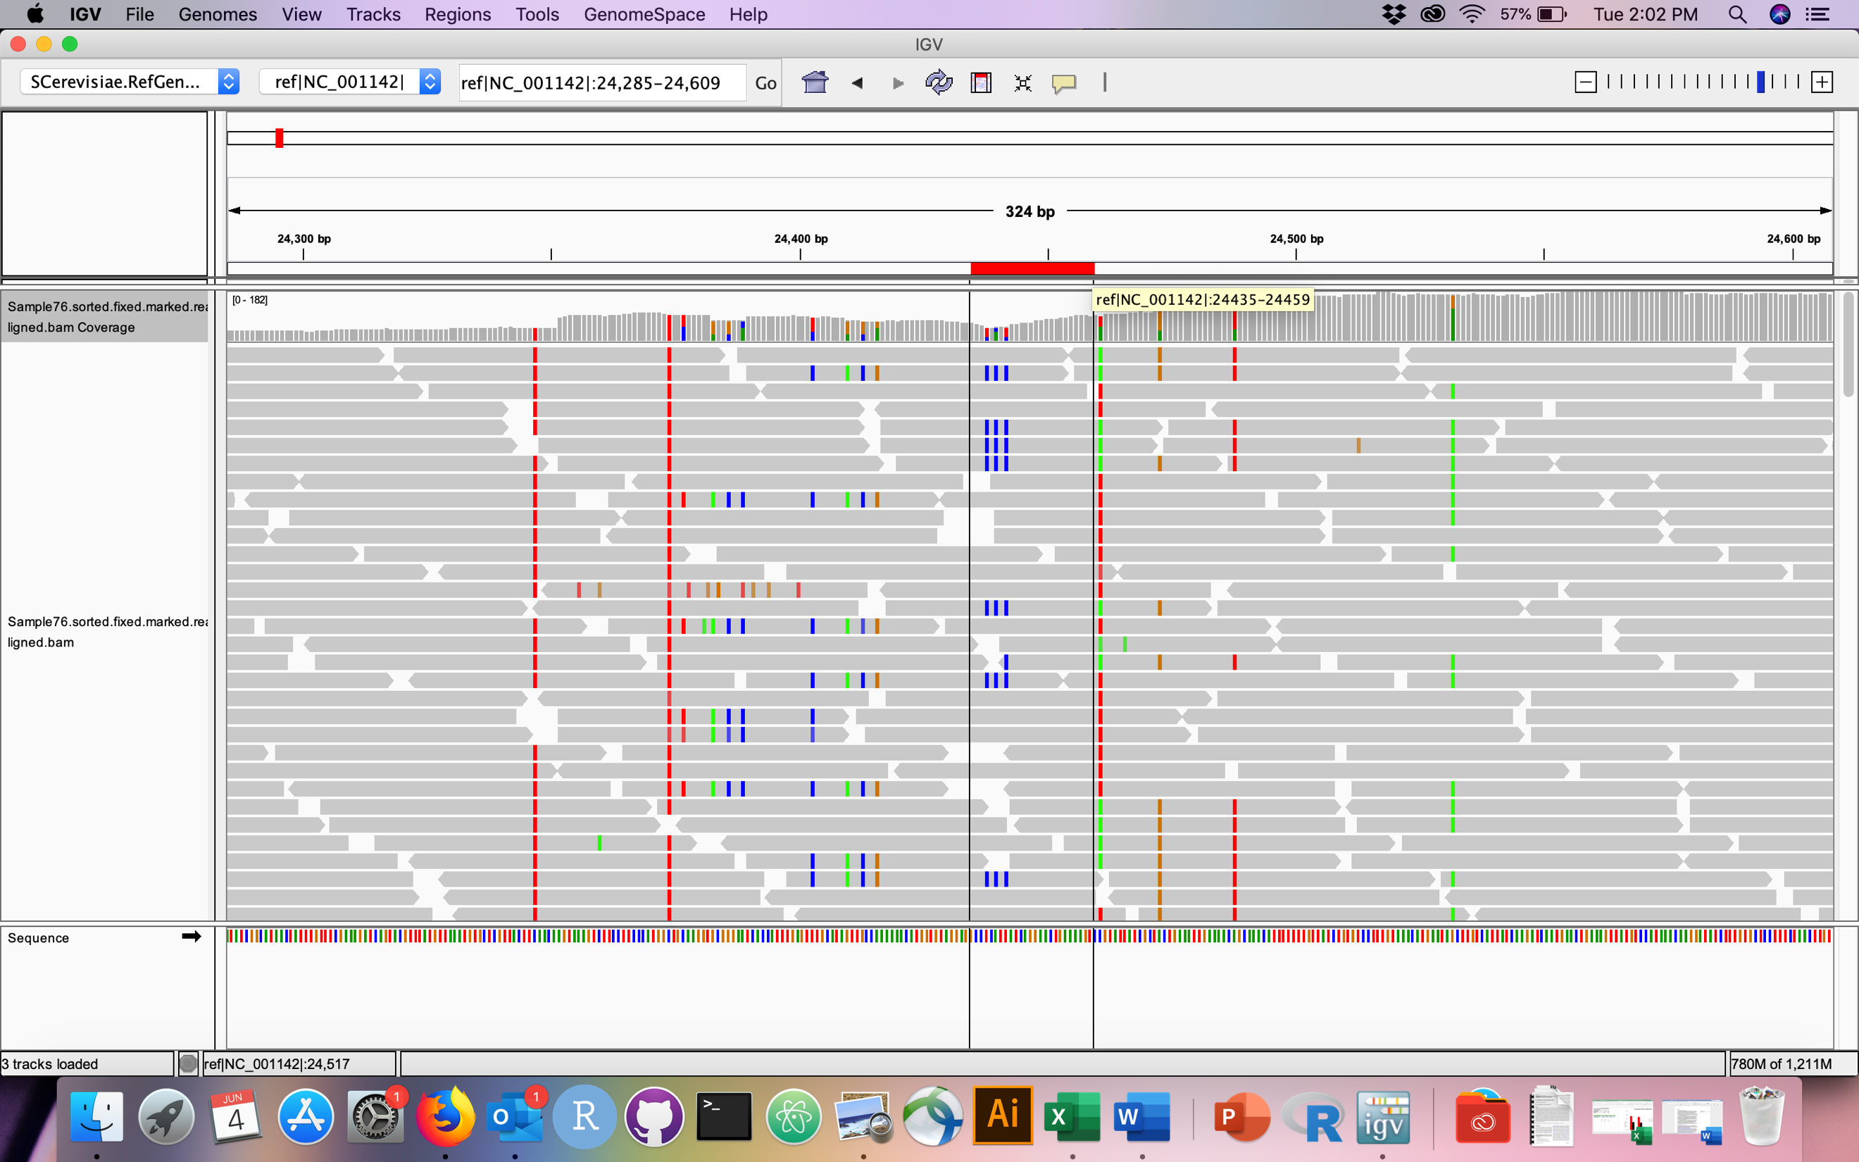

**Figure 2:** Integrated genome viewer (IGV) screenshot of the theorized initial breakpoint. Read count increases from an average of 80 to an average of 120 (1.5-fold difference – consistent with 3 copies of each duplicated allele).

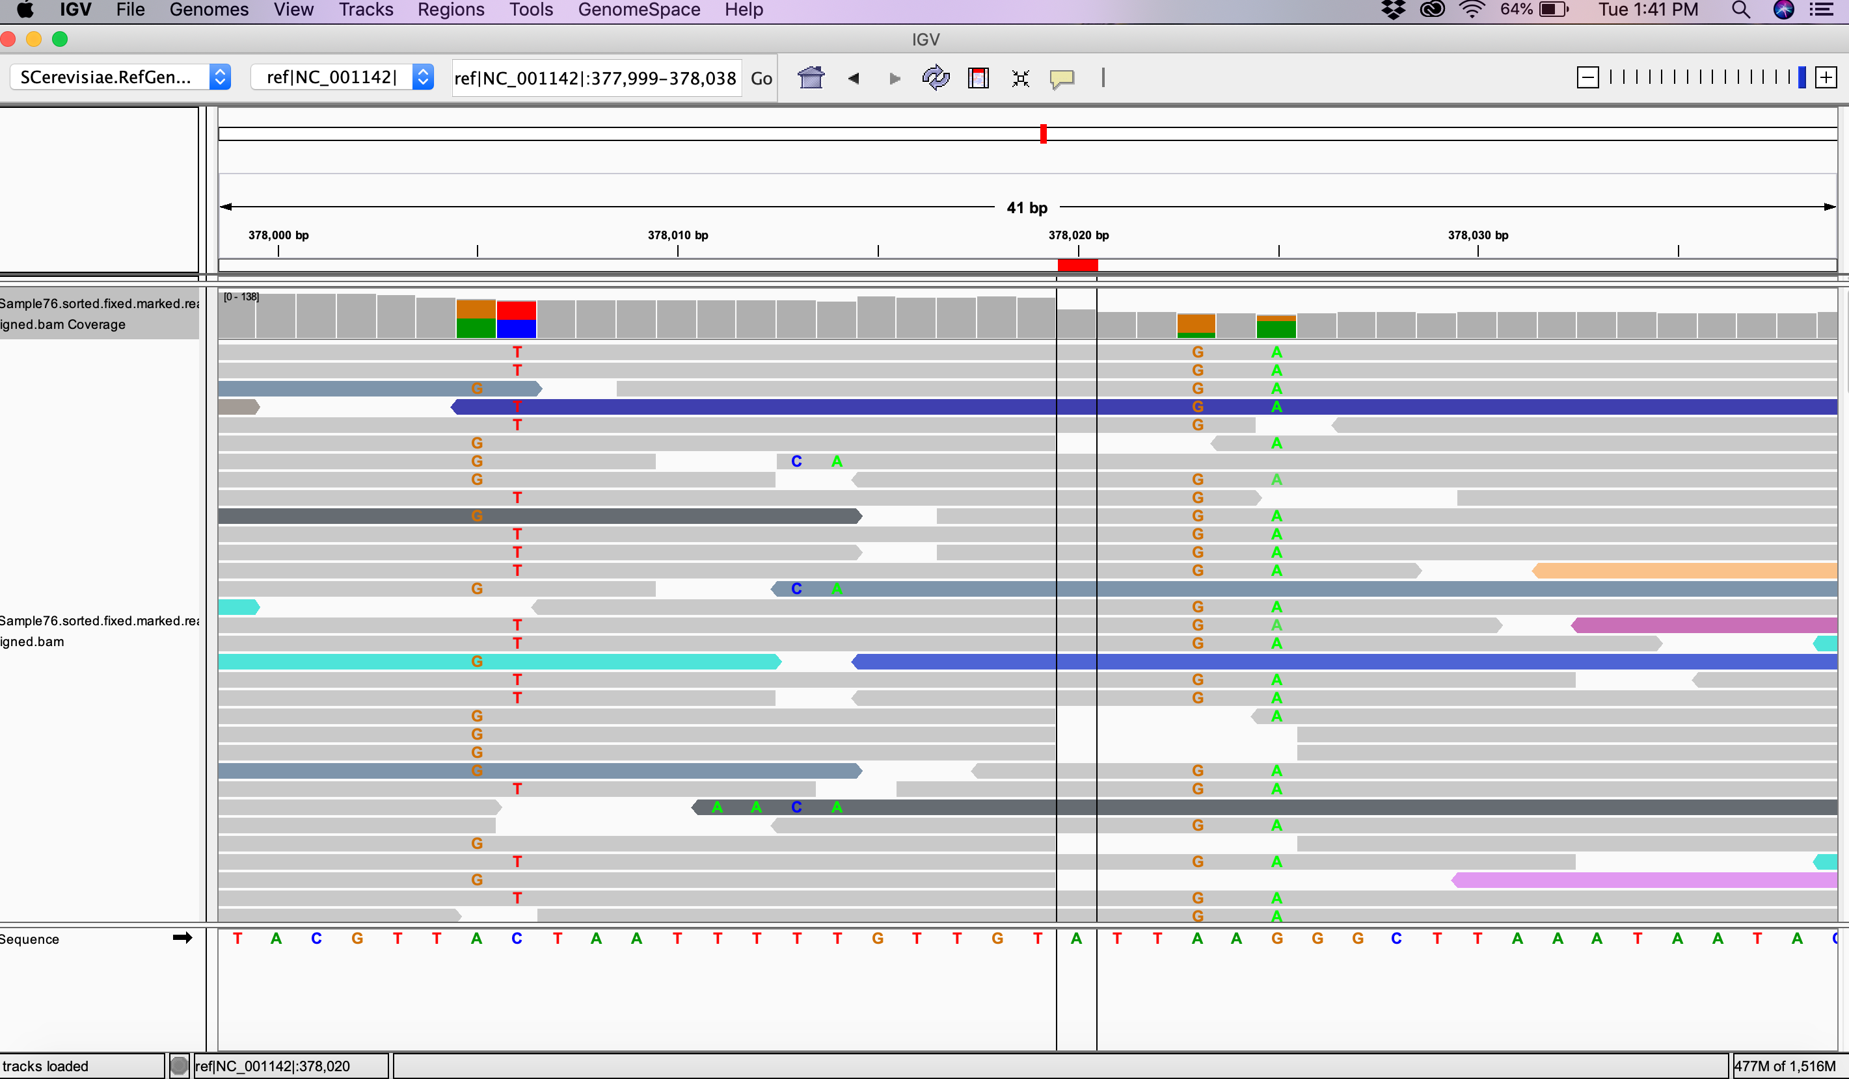

**Figure 3:** IGV screenshot of the theorized final breakpoint. Read count decreases from an average of 120 to an average of 80 (1.5-fold difference – consistent with 3 copies of each allele affected).

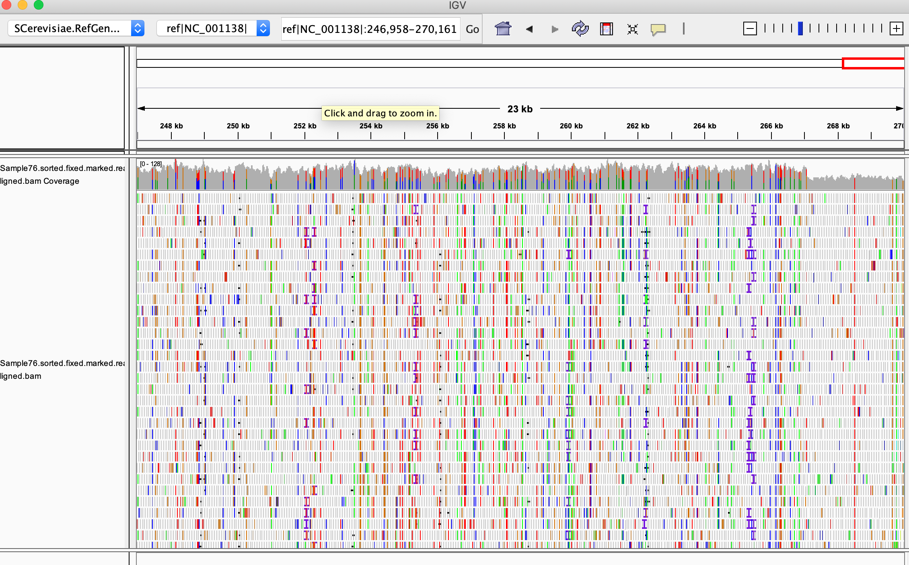

**Figure 4:** IGV screenshot of decrease in read count toward the end of chromosome VI: indicating a potential location of the duplicated arm of chromosome X in line 76.

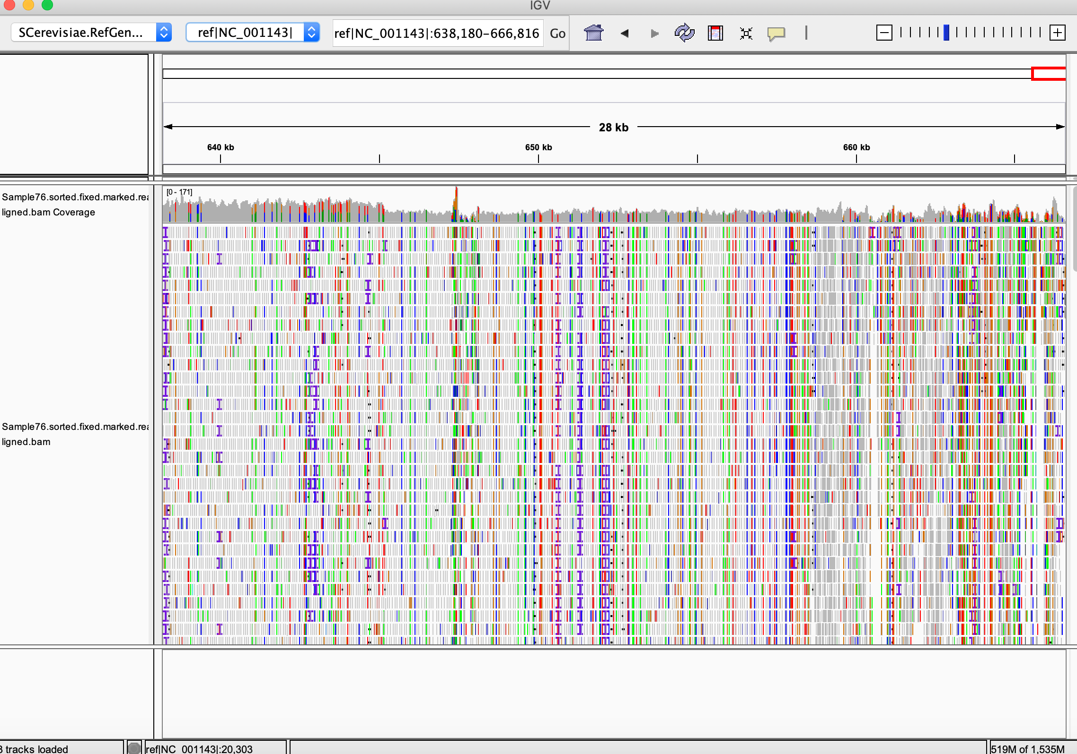

**Figure 5:** IGV screenshot of a decrease in copy number toward the end of chromosome XI, indicating a potential candidate for the location of the partially duplicated arm of chromosome X in line 76.



**Figure 6:** Heatmap depicting differential gene expression at the whole-chromosome level in aneuploid lines, when compared to ancestral expression levels.



**Figure 7:** Boxplots showing that gene expression levels (as measured by log2(FPKMratio) are as expected for aneuploid chromosomes. Boxes in blue represent monosomic chromosomes in the line, boxes in red represent trisomic chromosomes in the line, dark red boxes indicate tetrasomic chromosomes, pink represents partially duplicated chromosomes, and gray boxes are euploid chromosomes. Red line indicates expected log2 ratio for a 1.5x increase in gene dosage, and the blue line represents expected log2 ratio for a 0.5x decrease in gene dosage. Gray middle line indicates no change in gene dosage.



**Figure 8:** Ratio distribution of cis and trans genes for two lines with trisomy VIII. Red dotted line: average ratio compared to ancestor, black line: ratio of 1 (no change in dose compared to ancestor), green line: ratio of 0.5 compared to ancestor (expected for monosomic genes), magenta line: ratio of 1.5 compared to ancestor (expected for trisomic genes).

** This is an example of plots that I will include – I have a lot more, I just need to modify them to look like this one.

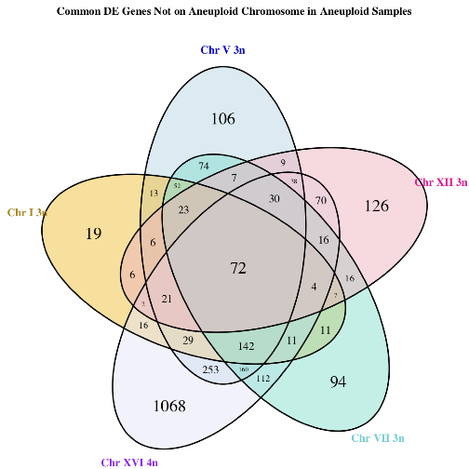

**Figure 9:** Aneuploids for different aneuploid chromosomes share differentially expressed genes located on euploid chromosomes

*** This is also an example of just one of the graphs I would add (and one way of displaying the information). I will make more of these with more data and include an alternative way of displaying the data.

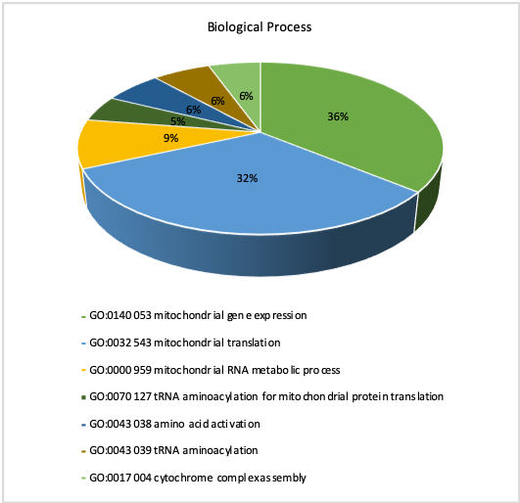

**Figure 10:** Hybrid euploid lines share a common gene expression signature, likely caused by mutation accumulation. GO analysis indicated that most of these genes are related to mitochondrial function.

** I still need to make one of these for lab strain samples.

**Figure 11:** Percentage of genes differentially expressed located on cis (aneuploid) chromosome and trans (non-aneuploid) chromosomes

**Figure 12:** Breakdown of genes on aneuploid chromosomes by compensation type. Shown is average percentage of genes on the given aneuploid chromosome. ** I will likely redo this later and make it look better.



Figure 13: Ratio distribution of all genes for 5 euploid lines from the hybrid ancestor experiment. Red dotted line: average ratio compared to ancestor, black line: ratio of 1 (no change in dose compared to ancestor), green line: ratio of 0.5 compared to ancestor (expected for monosomic genes), magenta line: ratio of 1.5 compared to ancestor (expected for trisomic genes).



Figure 14: Ratio distribution of all genes for 5 euploid lines from the lab strain ancestor experiment. Red dotted line: average ratio compared to ancestor, black line: ratio of 1 (no change in dose compared to ancestor), green line: ratio of 0.5 compared to ancestor (expected for monosomic genes), magenta line: ratio of 1.5 compared to ancestor (expected for trisomic genes).



**Figure 15:** Ratio distribution of cis and trans genes for three lines aneuploid for chromosome I. Red dotted line: average ratio compared to ancestor, black line: ratio of 1 (no change in dose compared to ancestor), green line: ratio of 0.5 compared to ancestor (expected for monosomic genes), magenta line: ratio of 1.5 compared to ancestor (expected for trisomic genes).



**Figure 16:** Ratio distribution of cis and trans genes for four lines aneuploid for chromosome V. Red dotted line: average ratio compared to ancestor, black line: ratio of 1 (no change in dose compared to ancestor), green line: ratio of 0.5 compared to ancestor (expected for monosomic genes), magenta line: ratio of 1.5 compared to ancestor (expected for trisomic genes).



**Figure 17:** Ratio distribution of cis and trans genes for two lines aneuploid for chromosome VII. Red dotted line: average ratio compared to ancestor, black line: ratio of 1 (no change in dose compared to ancestor), green line: ratio of 0.5 compared to ancestor (expected for monosomic genes), magenta line: ratio of 1.5 compared to ancestor (expected for trisomic genes).



**Figure 18:** Ratio distribution of cis and trans genes for two lines aneuploid for chromosome IX. Red dotted line: average ratio compared to ancestor, black line: ratio of 1 (no change in dose compared to ancestor), green line: ratio of 0.5 compared to ancestor (expected for monosomic genes), magenta line: ratio of 1.5 compared to ancestor (expected for trisomic genes).



**Figure 19:** Ratio distribution of cis and trans genes for two lines aneuploid for chromosome X. Red dotted line: average ratio compared to ancestor, black line: ratio of 1 (no change in dose compared to ancestor), green line: ratio of 0.5 compared to ancestor (expected for monosomic genes), magenta line: ratio of 1.5 compared to ancestor (expected for trisomic genes).



**Figure 20:** Ratio distribution of cis and trans genes for two lines aneuploid for chromosome XII. Red dotted line: average ratio compared to ancestor, black line: ratio of 1 (no change in dose compared to ancestor), green line: ratio of 0.5 compared to ancestor (expected for monosomic genes), magenta line: ratio of 1.5 compared to ancestor (expected for trisomic genes).



**Figure 21:** Ratio distribution of cis and trans genes for two lines aneuploid for chromosome XIV. Red dotted line: average ratio compared to ancestor, black line: ratio of 1 (no change in dose compared to ancestor), green line: ratio of 0.5 compared to ancestor (expected for monosomic genes), magenta line: ratio of 1.5 compared to ancestor (expected for trisomic genes).



**Figure 22:** Ratio distribution of cis and trans genes for one sample aneuploid for chromosome XV. Red dotted line: average ratio compared to ancestor, black line: ratio of 1 (no change in dose compared to ancestor), green line: ratio of 0.5 compared to ancestor (expected for monosomic genes), magenta line: ratio of 1.5 compared to ancestor (expected for trisomic genes).



**Figure 23:** Ratio distribution of cis and trans genes for two lines aneuploid for chromosome XVI. Red dotted line: average ratio compared to ancestor, black line: ratio of 1 (no change in dose compared to ancestor), green line: ratio of 0.5 compared to ancestor (expected for monosomic genes), magenta line: ratio of 1.5 compared to ancestor (expected for trisomic genes).

**Figure 24:** Plot indicating the average number of differentially expressed environmental response (ESR) genes in the aneuploid lines, arranged by chromosome. Plot also indicates the number of shared ESR genes between samples that are aneuploid for the same chromosome (genetic background and ploidy not taken into account). Chromosomes with no bars were not sampled in our analyses.

Gasch, A. P., P. T. Spellman, C. M. Kao, O. Carmel-Harel, M. B. Eisen *et al.*, 2000 Genomic expression programs in the response of yeast cells to environmental changes. Molecular biology of the cell 11**:** 4241-4257.

Kumaran, R., S.-Y. Yang and J.-Y. Leu, 2013 Characterization of chromosome stability in diploid, polyploid and hybrid yeast cells. PLoS One 8**:** e68094.

Marinoni, G., M. Manuel, R. F. Petersen, J. Hvidtfeldt, P. Sulo *et al.*, 1999 Horizontal transfer of genetic material amongSaccharomyces yeasts. Journal of Bacteriology 181**:** 6488-6496.

Mulla, W., J. Zhu and R. Li, 2014 Yeast: a simple model system to study complex phenomena of aneuploidy. FEMS microbiology reviews 38**:** 201-212.

Osley, M. A., and L. M. Hereford, 1981 Yeast histone genes show dosage compensation. Cell 24**:** 377-384.

Peter R. Eriksson, D. G., V. Nagarajavel, and David J. Clark, 2012 Regulation of Histone Gene Expression in Budding Yeast. Genetics 191**:** 7-20.

Torres, E. M., N. Dephoure, A. Panneerselvam, C. M. Tucker, C. A. Whittaker *et al.*, 2010 Identification of aneuploidy-tolerating mutations. Cell 143**:** 71-83.

Zhu, Y. O., M. L. Siegal, D. W. Hall and D. A. Petrov, 2014 Precise estimates of mutation rate and spectrum in yeast. Proceedings of the National Academy of Sciences 111**:** E2310-E2318.

Zillikens, M. C., S. Demissie, Y. H. Hsu, L. M. Yerges-Armstrong, W. C. Chou *et al.*, 2017 Erratum: Large meta-analysis of genome-wide association studies identifies five loci for lean body mass. Nat Commun 8**:** 1414.